BOS27 Manipulation R&D Cell Project Summary — Aug 25, 2022

Purpose

This document is to summarize the progress made towards the goal of optimizing and improving the Amazon Robotics Manipulation Manufacturing (ARMM) R&D cell at BOS27 with respect to both the short- and long-term vision during the months of June to August 2022. Additionally, this document recommends next steps for project completion and lessons learned throughout the project.

Background

The current ARMM R&D cell at BOS27 is 1740 sq. ft. within the Phase 2A production floor which envelops the original Robin production cell (“test cell”). Up until this point, this space has been used for training of associates on a pre-production Robin unit housed within the R&D cell, in addition to providing space for subassembly stations for the Robin production team. The test cell has been used for validation of functional tests for current Robin production units. There are two other R&D lab spaces within 2A, highlighted in red below in Figure 1. From left to right, MTAC has 2000 sq. ft., RIOS/TES has 420 sq. ft., and then ARMM’s 1740 sq. ft up to the right. The current position of the green mile is shown by the thick gray lines.

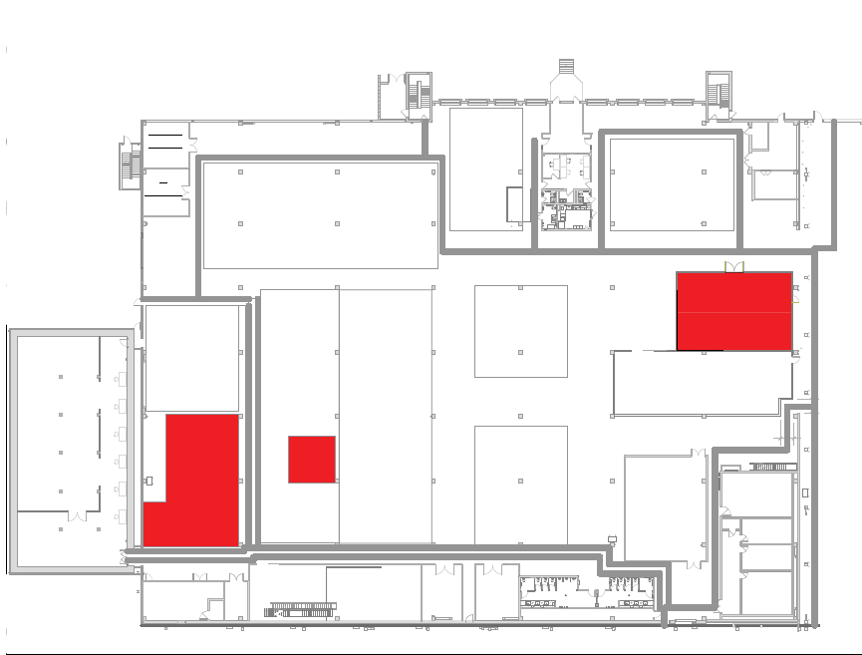

Figure 1: Current R&D Spaces

Goals & Deliverables

At project inception there were three main deliverables: (1) Creation of an optimized floor layout of the R&D cell for short term execution that provided better flexibility of the currently available space without requiring additional square-footage, (2) Development of a long-term solution to expand the R&D capabilities at BOS27 by relocating several GRD teams into a single, larger space designed with high collaboration in mind, and (3) Setup and outfit a collaborative Fanuc CRX collaborative robot (“cobot”) with the necessary equipment to showcase cobot capability and explore manufacturing automation opportunities for both ARMM and the Drive Unit production lines.

Results

1. Short-Term Layout - Complete

In order to create a layout that was sufficiently optimized for execution, requirements were gathered from seven stakeholder GRD teams including AME, PE, MTAC, RIOS, EHS, and others. The finalized list of requirements is captured in Appendix D. From this list, multiple iterations of possible layouts were derived for the current R&D cell using AutoCAD 2022, with feedback collected between major revisions.

The chosen short-term layout, Figure 2 below, captures the requirements from stakeholder teams and provides a flexible space for R&D work across multiple GRD teams. Robot storage is accomplished via pallet racking along one wall of the R&D cell, to which access is maintained by utilizing wheeled workbenches in the central open area. Additional workbenches are placed along the adjacent wall to the robot storage to provide adequate working space for several GRD teams simultaneously. The test cell has been expanded to 20ft. by 26ft. to match the Robin production cells, and a workspace has been set up for the Fanuc CRX cobot for Cobot Task Force development

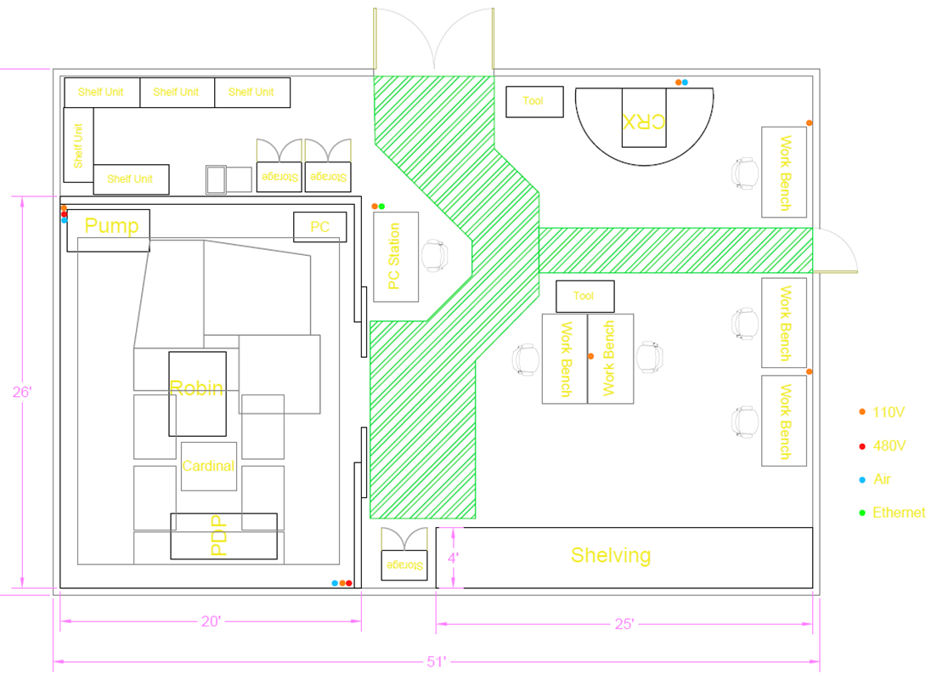

Figure 2: Short-Term Layout

1. Long-Term Layout - Complete

The long-term layout, shown in Figure 3 below, was generated using the same list of requirements in Appendix A in addition to a few strategic concepts. The first step was to consolidate the R&D cell into the existing MTAC cell at BOS27, situated off to the side of the production floor rather than right in the middle. This allows for more optimized manufacturing space in 2A. Secondly, to expand the capabilities of the R&D cell by including two larger test cells to allow for flexibility in development work on Cardinal, TCC, Sparrow, or unknown future manipulation projects.

By combining the ARMM, MTAC and TES cells into a single space, highlighted red in Figure 4 showing the whole Phase 2A space, and opening the doors to other GRD teams, better collaboration and space utilization are possible. A perfect example is the inclusion of a test cell. Both ARMM and MTAC spaces currently have a test cell in place for full-speed robot testing with all the safety equipment required, doubling both the occupied floorspace as well as the cost of components if left un-optimized.

The suggested layout includes storage for up to twelve pallets in several locations around the proposed cell, and the area above the pallets is available for lightweight item storage on shelf racking. This is to allow for storage of the four spare robots from the Robot Reuse program that now belong to ARMM, any additional pallets GRD teams may need stored, and also making better use of the vertical space available for small objects. With these locations in place around the exterior of the cell, the interior space can be fully utilized without allowances for PIT/WSS access and safety. The proposed layout also includes moving the green mile along the west wall of the 2A space to make better use of the manufacturing floorspace for future products. This change is reflected in Figure 4.

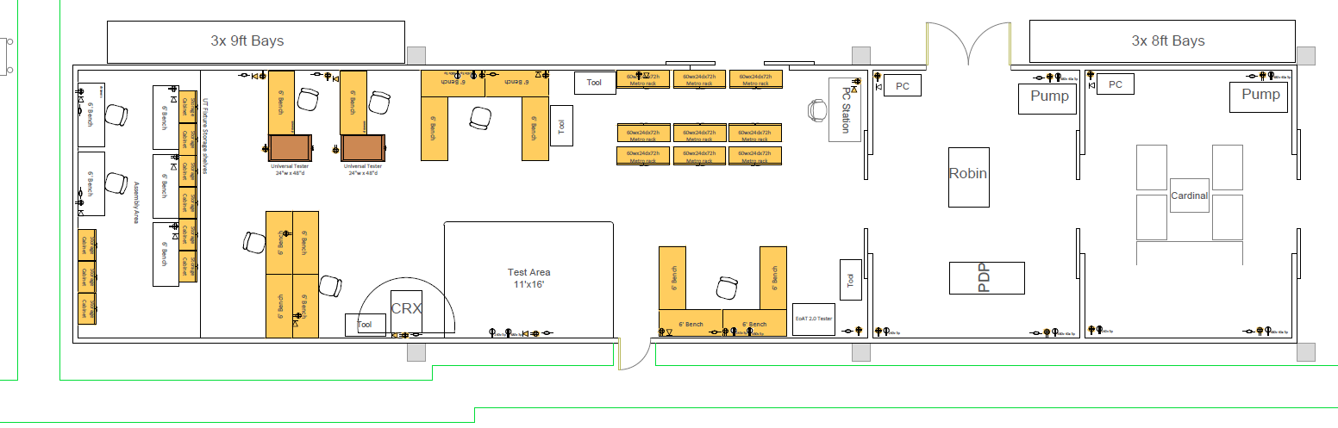

Figure 3: Proposed Long-Term Layout

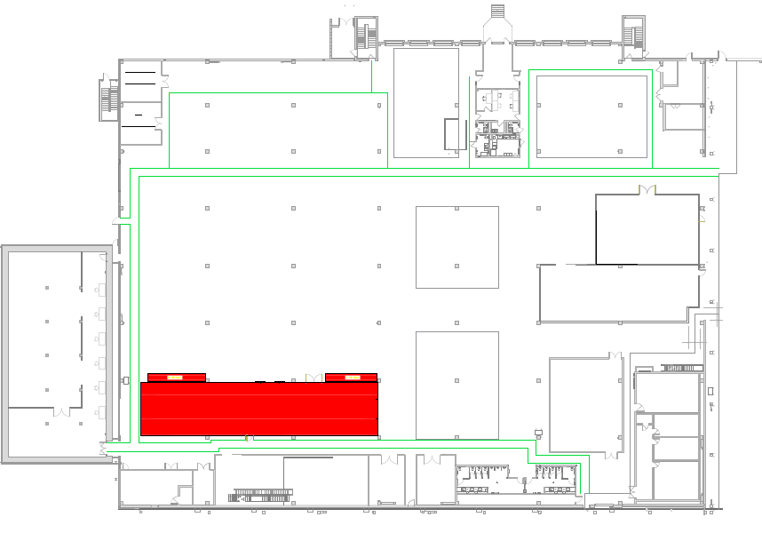

Figure 4: Proposed Layout Location

1. Collaborative Robot - Complete

Purchased in May 2022, the Fanuc CRX-10iA/L is a cobot with a 10-kilogram payload and a reach of 1.4-meters. Governed by ISO 10218-1 and ISO/TS 15066, what makes a cobot collaborative is the addition of external force detection such that the CRX comes to a stop should it contact an object or associate, reducing the required expensive safety infrastructure between cobots and associates. This feature allows cobots to interact directly with associates which opens up the possibilities of cobot assisted manufacturing.

Almost all robots, cobots included, require a mounting solution to anchor the robot to the ground. To accomplish this task, a custom rolling pedestal was designed to support the CRX (Appendix G). Vention was used as the supplier of choice due to their short lead times (<1 wk.), large part selection, and excellent online configurator. The primary supplier for EoAT components was EMI Corp., and for pneumatic components Festo was used as both are leaders in their industries. Through the setup process it was determined that an external power supply is required to provide power to digital peripherals, so Digi-Key was chosen to supply an external enclosure and the required electronics inside it. A full listing of suppliers used and contacted can be seen in Appendix F.

To better leverage the resources available, the program management team was pulled into the project to establish the “Cobot Taskforce”. Bi-weekly meetings are held to discuss the current state of the project, and the next steps to take. With this addition, a dedicated Slack channel (#ar-cobot-task-force) was also created for offline communications about the CRX cobot and its possible use cases in the production manufacturing space.

The primary target for initial automation is a portion of the assembly of Robin/Cardinal suction cups, demand for which is over 12,000 pieces, that are currently assembled by hand. The initial step is to remove the base piece from an un-indexed rack of parts and place it onto a hexagonal assembly tool. This step is well suited for a cobot compared to a conventional robot due to the compliant nature of cobots. The force sensors can be utilized to detect when engagement occurs, while rotating the part onto the tool. The associate may then install two of the more difficult parts onto the suction cup assembly, followed by the cobot capping the assembly and torqueing to spec using an automated torque driver.

Next steps

* Install fencing and infrastructure for future cell - **@Etobi, Target 10/7/2022 Completion**
* Functional part localization using Fanuc’s 2D iRVision system - **@Andyzli, Target 9/23/2022 Completion**
* Select and acquire a multi-use screw feeding/driving solution - **@Andyzli, Target 9/30/2022 Completion**
* Outfit CRX when Festo components arrive in October - **@Andyzli, Target 10/14/2022 Completion**
* Begin automation of suction cup assembly - **@Andyzli, Target 10/28/2022 Automation Start Date**

Summary

An optimized, flexible layout of the current ARMM R&D cell has been created, better utilizing the existing space. Execution of this layout is underway; however, in the spirit of Ownership, a pivot was made towards the long-term, future state layout sooner than originally anticipated to provide MTAC a space to prepare for Cardinal testing. The future state layout proposal that encompasses the requirements gathered and that allows for future expansion, flexibility, and increased capability moving forward was completed August 24th 2022 after approvals from the stakeholder teams were gathered. The final layout has been submitted through CBRE Program Manager (Etobi@) to the Architect (Leigh Spear – IA Interior Architects) and the team is awaiting a finalized drawing in return. Setup of the CRX cobot is nearly complete, awaiting the arrival of a few remaining pneumatic components estimated to be delivered mid-October. Once those parts are in-house the automation of suction cup assembly can begin testing in full. Captured in Appendix A are the primary lessons that were learned, relating to the project expectations and deliverables.

Appendices

Appendix A - Lessons Learned

* Gathering requirements from GRD teams took longer than anticipated due to busy schedules.
* Onboarding new suppliers in Coupa can be a lengthy process, one took a full month to complete.
* Just because a cobot is easy to use doesn’t mean nothing else is required to operate peripheral devices.
* Massachusetts requires less than 300’ safety egress from lab/R&D spaces, 400’ for manufacturing spaces.
* Massachusetts-specific 10’ high, 500lb maximum hoist and fire suppression requirements limit shelving.

Appendix B - FAQs

Throughout this project questions have come up regarding the future use of cobots at AR, the most common are addressed below.

1. **Why use cobots?**

Due to the dynamic POR change, classical industrial robots with hard coded motion planning are out of the question. Cobots are much faster to program due to the new drag and drop-style programming and iPad-like teach pendant. This cobot is the first step to enable manufacturing automation at AR.

1. **Are we looking to replace associates with cobots?**

No, the goal is to identify poor ergonomic tasks and make them more comfortable for our associates. Cobots take high risk items and make them safer while also improving quality.

Appendix C - Stakeholder List

* Andy Li (andyzli@) – Mentor/Advanced Manufacturing Engineering, Robotic Operations
* Chris Wise (clwise@) – Process Engineering, Robotic Operations
* Matteo Polcari (XXX@) – Process Engineering, Robotic Operations
* Marcus Boyle (marcboyl@) – Robotic Integration and Optimization Simulation (RIOS), TechDeployment
* Awadhesh Thakur (awathaku@) – Manufacturing Test and Controls (MTAC), Robotic Operations
* Eric Dickinson (dicerics@) – Process Engineering, Robotic Operations
* George Peshkov (peshkovg@) – MTAC, Robotic Operations
* Pete Groudas (groudas@) – MTAC, Robotic Operations
* Michael Toulouse (toulouse@) - Robotics Deployment Engineering, Robotics Operational Readiness, Robotics Integration Engineering, TechDeployment
* Namrata Shenoy (nshenoy@) – Environmental Health and Safety

Appendix D - Requirement List

|  |  |  |
| --- | --- | --- |
| Requirement | Items needed | Sq. ft. needed |
| Cobot space | 1 Cobot table + clear work envelope | 20 |
| RWC space | At least one 20’x26’ cell | 520 |
| Existing robot space | 2x M-710, 2x M-20 + pedestals + cabinets | 171 |
| Future robot space | 13+ Robots possible | 500+ |
| Tooling and spare parts storage | 5+ Shelf units | 50+ |
| Workbenches | At least 3 + PC Station | 120+ |
| Cabinets and toolboxes | 3 cabinets, 2 toolboxes | 55 |
| MTAC EoAT 2.0 tester | 1-2 tester units | 25-50 |
| IT connectivity | Ethernet for PC, good Wi-Fi |  |
| Utilities | Air, 110V, 230V, 480V |  |
| Lifting and material handling | Forklift/WSS access to racking |  |
| Floor anchoring | Larger mounting point in RWC for Cardinal, Sparrow, etc. |  |
| EHS concerns | Shelving, cobot, egress aisles |  |

Appendix E - Fanuc ISO Certification

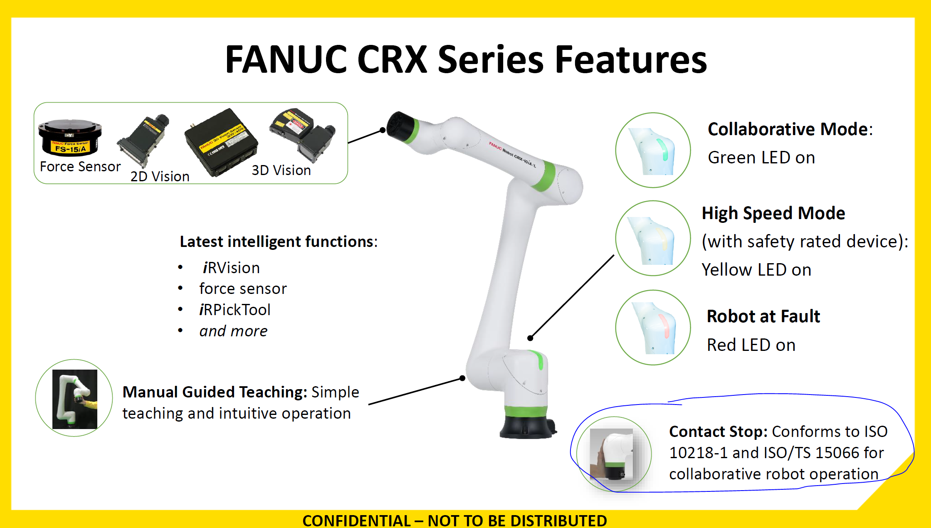

Appendix F - Supplier List

|  |  |  |  |
| --- | --- | --- | --- |
| Company | Use | POC | Email |
| Fanuc | CRX, iRVision manufacturer | Marc Celona | marc.celona@fanucamerica.com |
| Igus | Dresspack cable chain | Jonathan Burgess | jburgess@igus.net |
| Vention | Robot pedestal | Adam Farhat | adam.farhat@vention.cc |
| EMI Corp. | EoAT components | Tim Hill | timhill@emicorp.com |
| Festo | Pneumatic components | Michael Fallon | michael.fallon@festo.com |
| Digi-Key | Electrical components | N/A | orders@digikey.com |
| Controls For Automation | Vacuum generator | John Alicandro | johna@gocfa.com |
| Minuteman Automation Systems | Schunk distributor | Brendan Healey | bhealey@maseas.com |
| Leoni | Dresspack | Michael Manfredo | michael_manfredo@bizlinktech.com |
| Soft Robotics Inc. | Modular soft EoAT | Jeff DePree | jdepree@softroboticsinc.com |
| Motion Automation Intelligence | Cobot solutions | Josh Gustafson | josh.gustafson@ai.motion.com |
| Crown Equipment Corp. | Pallet racking | James Malacaso | james.malacaso@crown.com |
| Atlas Copco | Torque drivers | Ted Linstrum | ted.linstrum@atlascopco.com |

Appendix G - Vention Robot Pedestal

